*An exception may sometimes occur despite building highly reliable systems with zero bugs. When it does, it’s crucial to find its root cause and fix the problem.*

*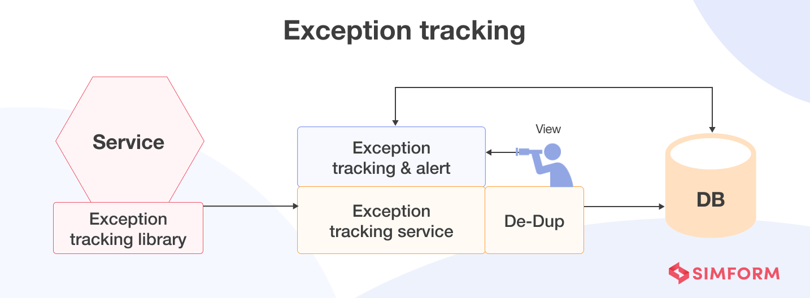*

*A better approach to managing exceptions in microservices is to use an exception-tracking service that works as a centralized repository of all the recorded exceptions. It de-duplicates exceptions, generates alerts, and informs developers to take appropriate action.*

*How does exception tracking facilitate observability?*

*Exception tracking offers a way of gaining early insight into production problems. When an exception occurs, you can track it back to its root cause and resolve the problem before it can impact systems or user experience.*

*Any reliable exception-tracking tool can record exceptions and share them with developers for rectification. Early problem detection and a proactive approach are crucial aspects of observability, and exception tracking aligns with those principles.*